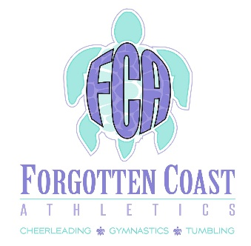
2023 Summer Camp Registration Form

Please Circle Camp(s) You are Signing Up For:

Gymnastics (June 20-22)

All-Star Cheer (July 25-27)

All Camps are from Tuesday – Thursday from 10:00am – 12:00 P.M.

All Camps will be Limited to the first 10 Athletes. Camp must be paid in full to hold spot. Each camp is $125.00 per athlete.
Drink and Snack Provided Each Day of Camp

All-Star Cheer Camp will consist of learning the ins and outs of All-Star Cheerleading. Jump technique and difficulty, Tumbling technique and difficulty, Stunt technique and difficulty, and Motion Technique! At the end of the week, they will showcase a routine they have put together to music.

Gymnastic Camp will consist of teaching athletes about all four apparatuses of gymnastics; Floor, Beam, Vault, and Bars. Athletes will learn the technique and difficulty behind all apparatuses and put together a routine for each element to perform at the last day of camp!

Athlete First Name:

Athlete Last Name:

Age:

Emergency Contact Name:

Emergency Contact Phone Number:

Each Camp Cost is $125.00
Forms and Payments May Be Submitted In-Person @ FCA or Online

Forgotten Coast Athletics
305 3rd St Port St Joe
850-889-8765
info@forgottencoastathletics.com www.forgottencoastathletics.com

