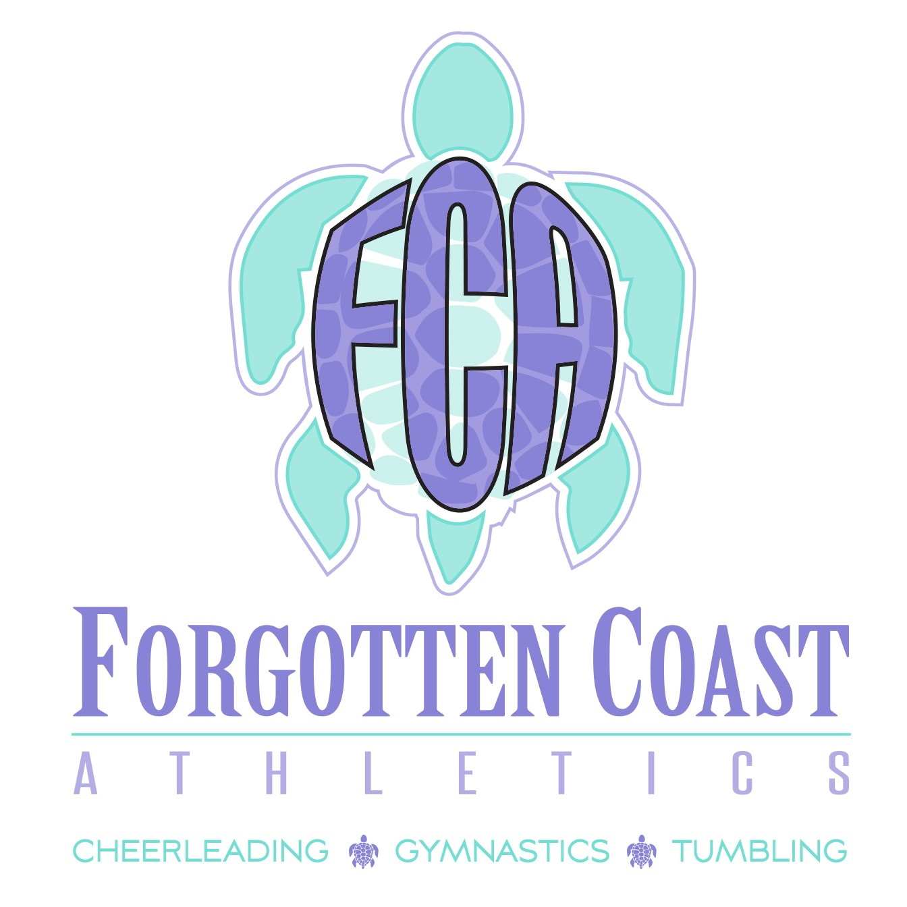
2026-2027 AFTERSCHOOL CAMP

WELCOME TO FCA
AFTERSCHOOL CAMP

Thank you for your interest in Forgotten Coast Athletics – Afterschool Camp. Please take the time to read all the information contained in this packet. Understanding this information will help in ensuring a fun, successful, and efficient 2026-2027 Afterschool Camp.

IMPORTANT DATES

May 18th, 2026 Registration Begins
August 10th, 2026 Camp Begins
September 7, 2026 No Camp - Closed for Labor Day
October 12 and 13 , 2026 No Camp - Closed for Fall Break
November 11, 2026 FCA Closed for Veterans Day
November 23 – 27, 2026 No Camp - Closed for Thanksgiving
Dec 21, 2026 – Jan 4, 2027 No Camp - Closed for Christmas & New Years
January 18, 2027 No Camp – Closed for MLK JR Day
February 17, 2027 No Camp – Closed for President’s Day
March 15 - 19, 2027 No Camp - Closed for Spring Break
March 26th, 2027 No Camp – Closed for Easter
May 28, 2027 Last Day of Camp

*NOTE: IF A SCHOOL DAY IS CANCELLED THROUGOUT THE YEAR, REGARDLESS OF REASON, FCA AFTERSCHOOL CAMP FOR THAT DAY WILL BE CANCELLED AS WELL.

FCA will have AFTERSCHOOL CAMP on the following Days for Teacher Inservice. On these days Camp will go from 12:00 to 6:00. We will have pizza and drinks for the children and fun activities planned. You will need to plan on dropping your child off at FCA.
September 25th, 2027
October 30th, 2027
May 28- Last Day of School (Half-day and FCA will pick up kids)

AFTER SCHOOL CAMP
(3:00PM – 6:00PM Monday Thru Friday)
CAMP IS LIMITED TO THE 1ST 26 ATHLETES TRANSPORTATION IS NO LONGER PROVIDED BY SCHOOL DISTRICT
THERE WILL BE TRANSPORTATION PROVIDED BY FCA FROM PSJE TO FCA

Dedicated Area at FCA for Afterschool Camp
Tumbling
Gymnastics
Cheerleading
Games
Homework
Drinks Provided Daily
Snacks Provided Daily

PAYMENTS
Discounts Will Be Given for Current FCA Athletes Enrolled in Competition Teams or Rec Classes as Listed Below. This Takes into Account Possible Overlap Between the Afterschool Camp and Team Practice Schedules.
10 Months – August Thru May
Dates Listed on “Important Dates” Page are Already Taken into Account in the Monthly Pricing Rates Listed Below
($350 Per Month Non-FCA / $300 Per Month FCA)
Aug, Sept, Oct, Nov, Dec, Jan, Feb, Mar, Apr, May
Annual Paid In Full Discount – ($3,500 Non-FCA / $3,000 FCA)
***3.9 PROCESSING FEE ON ALL TRANSACTIONS! ***
Monthly Payments are Due the 1st of the Month. If Payment is Not
Received by the 10th, a late charge of $30 Will Be Added to the Account.
First Month Payment Required to Hold Afterschool Camp Spot
If Your Athlete Decide to Take a Month Off, The Next Person on the Waiting List Will Take that Spot and Your Athlete Will Be Put on the Waiting List
No Other Discounts or Refunds Will Be Given
If an Athlete’s Monthly Payment is Not Made by the 10th of the Month, the Athlete will Not be Able to Attend the After School Camp Until the Outstanding Payment is Made and May Lose His/her Camp Spot.
Pickup Time is 6:00pm. Please No Late Pickups. The Athlete’s Account Will Be Charged $15 for Everything 15 Minutes the Athlete is Late Being Picked Up

PAYMENTS

Making sure the Athlete’s account status is up to date is the responsibility of the parent/athlete.

FCA will accept the following forms of payment credit card or ACH using the online shopping cart through GoMotion.
All payments must go through GoMotion for the 26-27 school year.
Monthly payments are due the 1st of the Month. If payment is not received by the 10th, a late charge of $30.00 will be added to your account.

AFTERSCHOOL CAMP REGISTRATION

Athlete’s Full Legal Name:_________________________________________
Athlete’s Address:________________________________________________
Athlete’s DOB:____________________________________________________
Parent Guardian Name:____________________________________________
Parent/Guardian Phone:___________________________________________
Parent/Guardian Email:____________________________________________
Other Emergency Contact Name:__________________________________
Other Emergency Contact Phone:__________________________________

AUTHORIZATION, LIABILITY RELEASE, INDEMNITY AGREEMENT
& MEDICAL RELEASE FOR FORGOTTEN COAST ATHLETICS
Authorization. For good and valuable consideration, the receipt and sufficiency of which are hereby acknowledged, I __________________________, as parent or legal guardian of _____________________________, a minor (hereinafter “Minor”), hereby grant any permission necessary to allow Minor to participate in athletic and related activities, including but not limited to all aspects of gymnastics, tumbling, trampoline, dance and/or cheerleading, training and/or competition (hereinafter “Activities”), to be conducted by Forgotten Coast Athletics, 305 Third Street, Port St. Joe, Florida 32456, Stephanie Petersen and Tim Petersen. In addition, I give Forgotten Coast Athletics, Stephanie Petersen and Tim Petersen to film, photograph or videotape the above Minor for any reproductions, movies, televised events, or promotional, marketing or print-associated materials in any way connected with Forgotten Coast Athletics.
Liability Release. I am fully aware that any activity involving motion, height, or other athletic activity, including that Activities specified herein, creates the possibility of serious injury and/or death to Minor. Nevertheless, I, in my own behalf and on behalf of Minor, further agree to release and to hold harmless forever the Forgotten Coast Athletics, Stephanie Peterson and Tim Petersen, on whose premises at 305 Third Street, Port St. Joe, Florida 32456 the activities will occur (hereinafter the “Location”), and the respective owners, directors, officers, representatives, members, agents, shareholders and employees of Forgotten Coast Athletics, Stephanie Petersen and Tim Petersen (hereinafter collectively “Releasees”) from any and all liability to me, the above-named Minor and any other person whether caused by the negligence (whether gross, willful, wanton or otherwise) of the Releasees or otherwise for any claim, judgment, loss, liability, cost and expenses (including, without limitations, attorney's fees and costs) arising out of or connected with the Activities, including any claim arising out of or connected with any illness or injury (minimal, serious, catastrophic and/or death) Minor may incur or sustain during the Activities and while traveling to and from the Location whether or not the Activities actually occur. This release of liability includes but is not limited to any claims of negligence, dangerous condition, latent defect, premises liability, code violation, negligent security, failure to warn, vicarious liability, product defect, negligent hiring, negligent supervision, negligent maintenance, or improper/dangerous equipment; it is intended to be as broad as is permissible under Florida law. I am fully aware of the nature of the Activities provided and the possibility of injuries arising from such Activities. This release is intended to be binding upon the Minor, his/her heirs, assignees, successor(s) in interest and anyone claiming by or through him/her.
I understand and agree that, by signing this Release, none of the Releasees may be held liable or responsible in any way for any injury, death, or other damages to me, the Minor, or our family, heirs or assigns that may occur as a result of Minor’s participation in any of the Activities or as the result of the negligence of any of the Releases, whether passive or active. I, in my own behalf and on behalf of Minor, hereby warrant that I have read this Liability Release in its entirety and fully understand its contents. I, in my own behalf and on behalf of Minor, am aware this Liability Release forever releases Releasees from liability and contains an acknowledgement of my voluntary and knowing assumption of the risk of injury or illness. I, in my own behalf and on behalf of Minor, further acknowledge that nothing in this Liability Release constitutes a guarantee that the Activities occur.

Indemnity Agreement. I further expressly agree to indemnify, defend and hold harmless Releasees and Releasees’ heirs, successors, assigns, executors and administrators against loss from any further claims, damages, demands or actions that may subsequently be brought by Minor or by any other persons on the account of damages of any character resulting to Minor in any way from the foregoing Activities. I further agree to reimburse and to make good to Releasees any loss or costs (including attorney’s fees) Releasees may have to pay as a result of any such action, claim, or demand, including any costs, loss and/or attorney’s fees related to any legal action that may be necessary or appropriate to enforce the terms of this Agreement.
I, in my own behalf and on behalf of Minor, have signed this document voluntarily and of my own free will.
Medical Release. I, in my own behalf and on behalf of Minor, acknowledge and agree that such participation in Activities subjects Minor to possibility of physical illness or injury (minimal, serious, catastrophic and/ or death) and that I, in my own behalf and on behalf of Minor, acknowledge that Minor is assuming the risk of such illness or injury by participating in the Activities. In the event of such illness or injury, I authorize Forgotten Coast Athletics, Stephanie Peterson and/or Tim Petersen to obtain necessary medical treatment of Minor and hereby, in my own behalf and on behalf of Minor, release and hold harmless Releasees in the exercises of this authority. I further acknowledge and understand that I will be responsible for any and all medical and related bills that may be incurred on behalf of Minor for any illness or injury that Minor may sustain during the Activities and while traveling to and from the site for the activity whether or not the activity actually occurs.
THE UNDERSIGNED HAS READ, UNDERSTOOD, AGREES WITH AND VOLUNTARILY SIGNS THE AUTHORIZATION, LIABILITY RELEASE, INDEMNITY AGREEMENT & MEDICAL RELEASE, and further agrees that no other oral representations, statements or inducements apart from the foregoing written agreement have been made. I further expressly agree that the foregoing AUTHORIZATION, LIABILITY RELEASE, INDEMNITY AGREEMENT & MEDICAL RELEASE is intended to be as broad and inclusive as is permitted by the law of Florida and that if any portion thereof is held invalid, it is agreed that the balance shall, notwithstanding, continue in full legal force and effect.

SIGNATURE:______________________________________ DATE: ___________________

