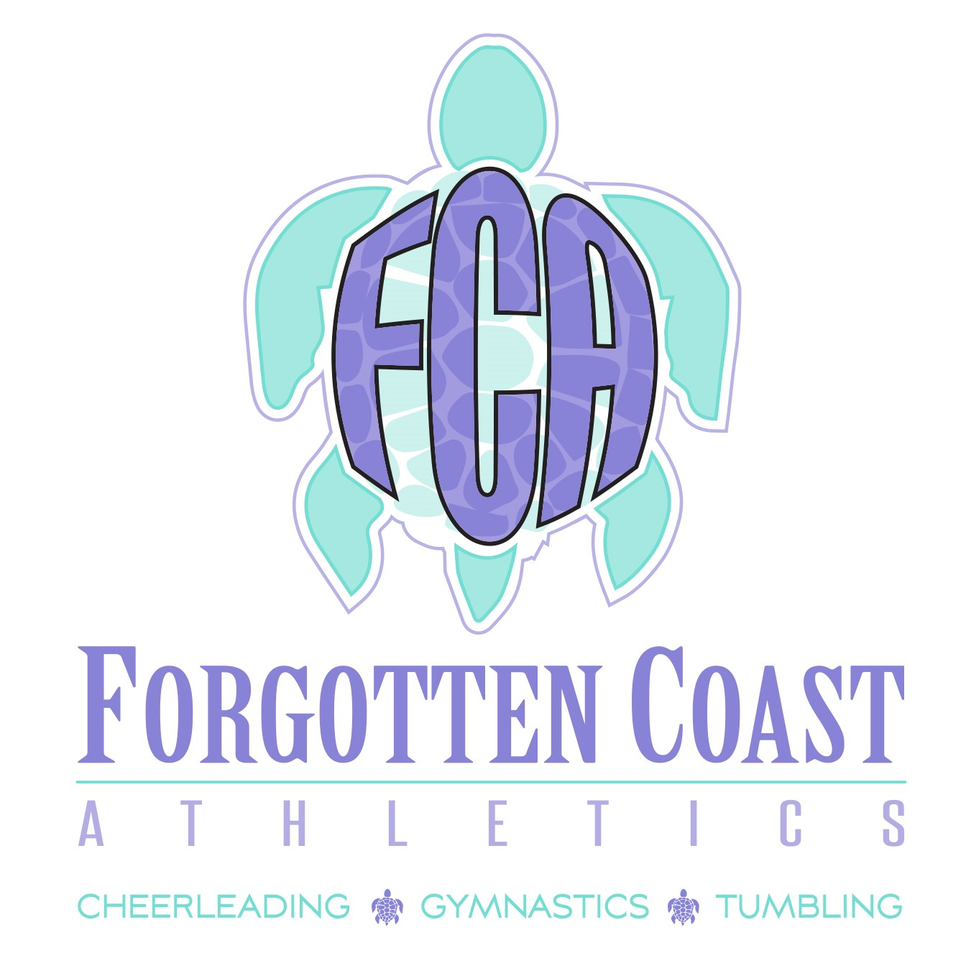

**2025-2026 SIGN-UP PACKET**

**WELCOME TO FCA**

**REC TUMBLING - REC GYMNASTICS**

Thank you for your interest in Forgotten Coast Athletics – Rec Tumbling and Rec Gymnastics. We look forward to the upcoming 2025-2026 season. Please take the time to read all the information contained in this packet. Understanding this information will help in ensuring a fun, successful, and efficient 2025-2026 season.

**IMPORTANT DATES**

July 28, 2025 Registration Begins

August 7, 2025 Open House

August 12, 2025 Classes Begin

September 1, 2025 FCA Closed for Labor Day

October 13 and 14 , 2025 FCA Closed for Fall Break

November 24- 28, 2025 FCA Closed for Thanksgiving

Dec 24, 2025 – Jan 4, 2026 FCA Closed for Christmas and New Years

January 19, 2026 FCA Closed for MLK Day

February 16, 2026 FCA Closed for President’s Day

March 16-20, 2026 FCA Closed for Spring Break

April 3-6, 2026 FCA Closed for Good Friday/ Easter

May 21, 2026 Last Day of Rec Season

**REC TUMBLING AND REC GYMNASTICS INFORMATION**

No Tryouts Required

See “Proposed Class Schedule” Section for Classes Offered

No Special Uniforms/Practice Wear Required

Wear Something COMFORTABLE

Shorts and Tee Shirt

Leotard

Athletes Wear CLEAN Shoes (Rec Tumbling). Barefoot (Rec Gymnastics)

**PAYMENTS**

Making sure the Athlete’s account status is up to date is the responsibility of the parent/athlete.

Monthly tuition for 1 class (60 minutes once a week) is $70.00 with a registration fee of $40.00

2 classes for $120.00 a month

3 classes for $150.00 a month

Athletes WILL NOT be able to participate in class if payment has not been made. Athlete’s name will not be on the attendance sheet if the athlete is not registered for the class.

\*\*\***3.9 PROCESSING FEE ON ALL TRANSACTIONS! \*\*\***

**\* Monthly Payments are Due the 1st of the Month. If Payment is Not**

**Received by the 10th, a late charge of $30 Will Be Added to the Account.**

**FCA WILL ACCEPT THE FOLLOWING FORMS OF PAYMENT:**

**Credit Card or ACH – Use the Online Shopping Cart through GoMotion:**

[**https://www.gomotionapp.com//team/flfca/page/class-registration**](https://www.gomotionapp.com//team/flfca/page/class-registration)

**PROPOSED CLASS SCHEDULE**

**(Limited to 20 Tumbling Athletes and 20 Gymnastics Athletes Per Class)**

|  |  |  |
| --- | --- | --- |
| Gymnastics Beginners | Tuesday | 6:00-7:00pm |
| Gymnastics Advanced | Tuesday | 7:00-8:00pm |
| Level 1 Tumbling | Thursday | 6:00-7:00pm |
| Level 2 Tumbling | Thursday | 7:00-8:00pm |