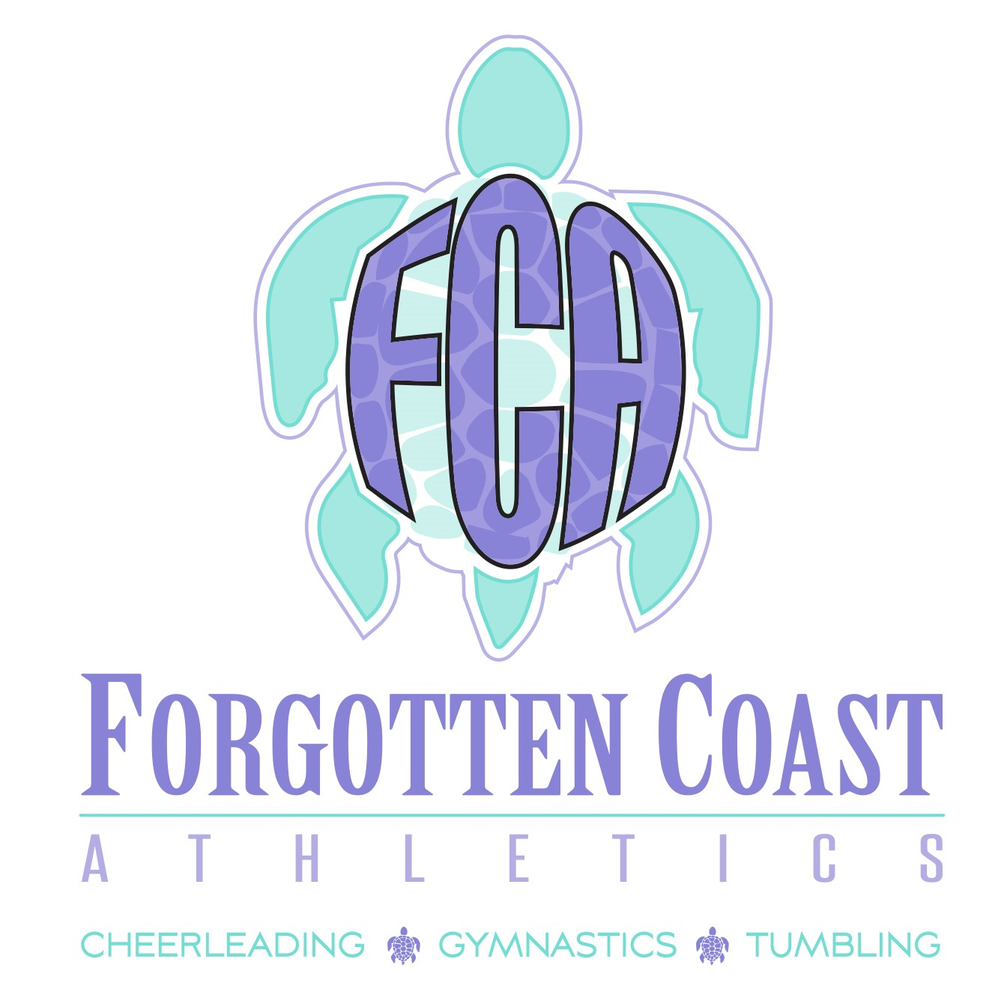
2023-2024 SIGN-UP PACKET

WELCOME TO FCA
REC TUMBLING - REC GYMNASTICS

Thank you for your interest in Forgotten Coast Athletics – Rec Tumbling and Rec Gymnastics. We look forward to the upcoming 2023-2024 season. Please take the time to read all the information contained in this packet. Understanding this information will help in ensuring a fun, successful, and efficient 2023-2024 season.

IMPORTANT DATES

August 1, 2023 Registration Begins
August 11, 2023 Open House
August 14, 2023 Classes Begin
September 4, 2023 FCA Closed for Labor Day
October 16 and 17 , 2023 FCA Closed for Fall Break
November 20- 24, 2023 FCA Closed for Thanksgiving
Dec 20, 2023 – Jan 3, 2024 FCA Closed for Christmas and New Years
January 15, 2024 FCA Closed for MLK Day
February 19, 2024 FCA Closed for President’s Day
March 18-22, 2024 FCA Closed for Spring Break
March 29, 2024 FCA Closed for Good Friday/ Easter
May 17, 2024 Last Day of Rec Season

REC TUMBLING AND REC GYMNASTICS INFORMATION

No Tryouts Required
See “Proposed Class Schedule” Section for Classes Offered
No Special Uniforms/Practice Wear Required
Wear Something COMFORTABLE
Shorts and Tee Shirt
Leotard
Athletes Wear CLEAN Shoes (Rec Tumbling). Barefoot (Rec Gymnastics)

PAYMENTS
Making sure the Athlete’s account status is up to date is the responsibility of the parent/athlete.
Athlete WILL NOT be able to participate in class if payment has not been made. Athlete’s name will not be on the attendance sheet if the athlete is not registered for the class.
FCA WILL ACCEPT THE FOLLOWING FORMS OF PAYMENT:
Credit Card or ACH – Use the Online Shopping Cart through GoMotion:
https://www.gomotionapp.com//team/flfca/page/class-registration

PROPOSED CLASS SCHEDULE
(Limited to 20 Tumbling Athletes and 20 Gymnastics Athletes Per Class)

Tumbling Intermediate (Level 1) | Monday | 4:00pm-5:00pm
Tumbling Beginners | Monday | 5:00pm-6:00pm
Gymnastics Beginners | Thursday | 5:00pm-6:00pm
Gymnastics Advanced | Thursday | 6:00pm-7:00pm

